Bahria University

# Computer Science Department



**Submitted By:**

* MUHAMMAD FARAZ
* ENROL:02-134171-147
* BS(CS)_4B
* REGISTRATION NUMBER:48536

**Submitted to:**

* Miss Laraib Tahir

**Submission Date:**

[30/09/2018]

**DEPARTMENT OF COMPUTER SCIENCE**

**BAHRIA UNIVERSITY, KARACHI CAMPUS**

|  |
| --- |
| EXERCISES |
|

**TASK #01**

1. Create a new table EMPLOYEE replica of EMP table with no records in it. Create a new table DEPART replica of DEPT table with all the records in it. Create a primary foreignkey relationship between EMPLOYEE and DEPART tables.

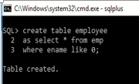

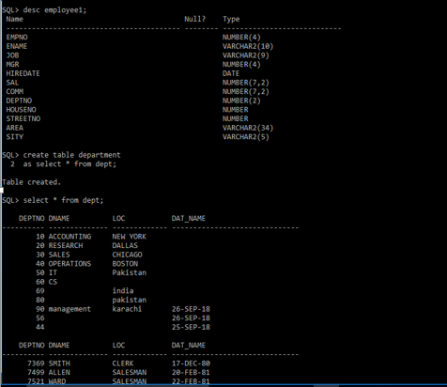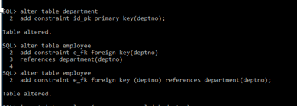

**Task # 02**

Insert following records into EMPLOYEE using following values:

EMPNO = 101, ENAME = WASEEEM, SAL = 5000, JOB = CLERK and DEPTNO = 20.

EMPNO = 102, ENAME = SAJID, SAL = 15000, JOB = ANALYST and DEPTNO = 10.





**Task # 03**

Change the record inserted in question 2 from ENAME ‘WASEEM’ to ‘KHALID’ and SAL

5000 to 10000.

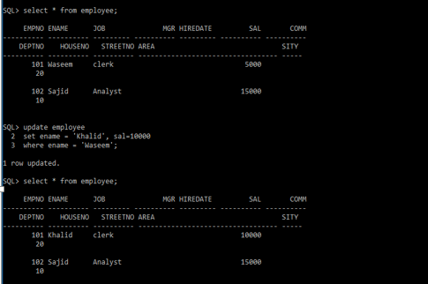

**Task # 04**

Remove all the records from EMPLOYEE table having job = ‘ANALYST’.

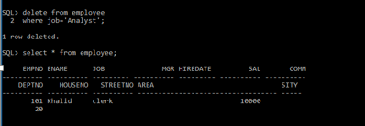

**Task # 05**

Try to update the table DEPART and change the value of DEPTNO from 10 to 30. Find the

error and give the reason for the error.

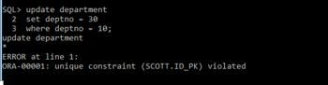

**Reason:** Cannot be updated since it is a primary key and two rows can have not the same number

**Task # 06**

Insert a new record into EMPLOYEE using following values:

EMPNO = 103, ENAME = SALEEM, SAL = 60000, JOB = ANALYST and DEPTNO = 65.

Find the error and give the reason for the error.

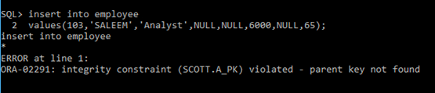

**Reason:**

It cannot be insert because no primary key has foreign key value.